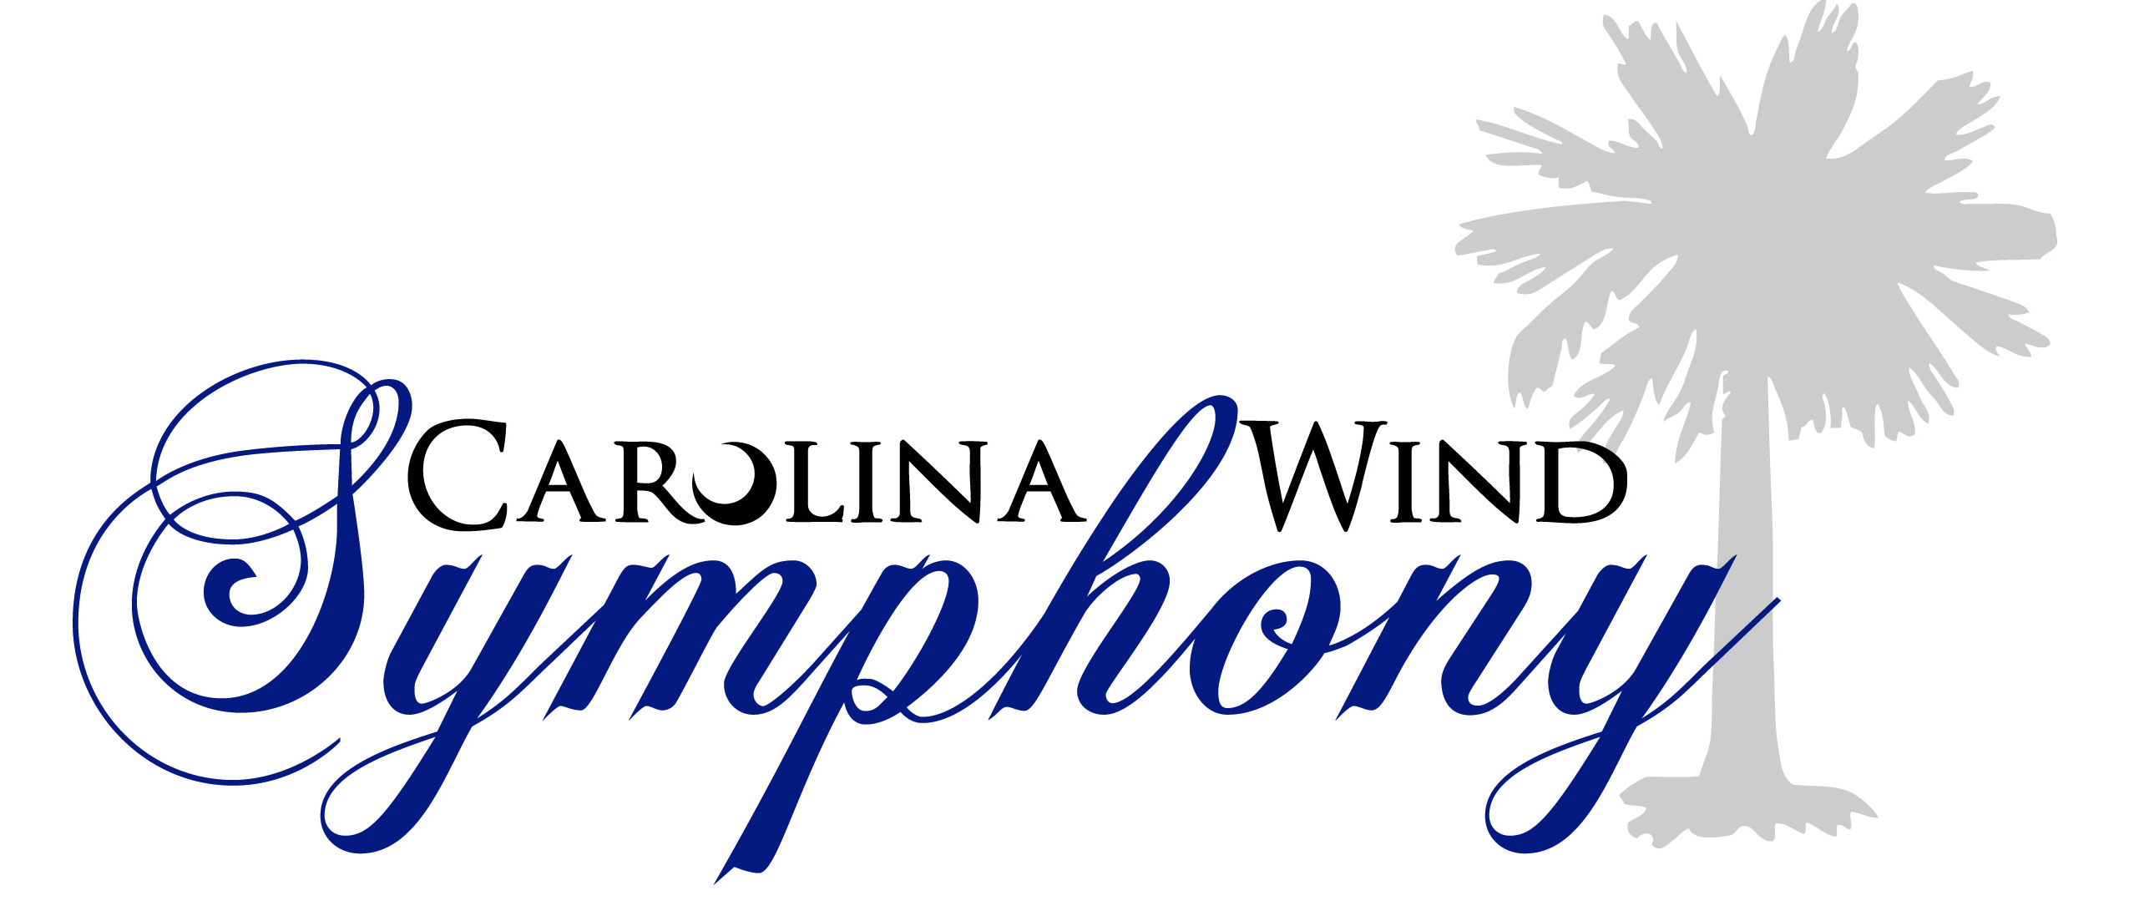

Silent Auction Donation Form
Monday April 28, 2014
6:30 – 9:30 PM
Saluda Shoals Park – River Center

CWS member name:
Donor information
Company/Donor name:
Representative (if applicable):
Address:
Phone:
Email:
Donation detail: Description (please be specific with details, time restrictions, age requirements, etc.)
Item Description: |  |  | Estimated Value:
Total estimated value:

Thank you for your donation to the Carolina Wind Symphony Silent Auction!
We are a non-profit organization supported by member dues and donations from the general public. This document will serve as your receipt for tax purposes. Please note: we are not in a position to determine the value of your donation at the time of the donation. Please consult your tax advisor. No goods or services were provided in return for this donation.

